Core Concepts and Flow Explanation
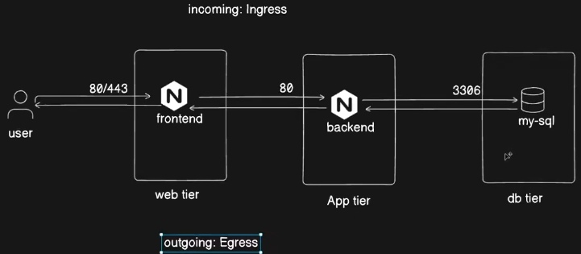
Network Flow in Multi-Tier Applications:
The example used is a three-tier web application with:
    - Web/Front-end tier: exposed on ports 80/443 (HTTP/HTTPS).
    - Application/Back-end tier: handles business logic, also exposed on port 80.
    - Database tier: running MySQL on port 3306.
  - User requests enter the web tier (Ingress), flow internally between tiers, and responses exit the system (Egress).
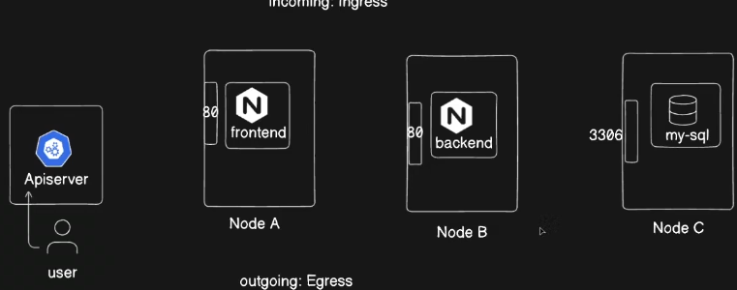
Kubernetes Context:
  - The same 3-tier architecture is deployed across multiple Kubernetes nodes.
  - Pods host the front-end, back-end, and database applications.
  - Pods are exposed via Services on specific ports (80, 3306).By default, all pods and services can communicate with each other without restriction in Kubernetes clusters.

Importance of Network Policies
- Kubernetes’ default behavior allows unrestricted communication among pods and services → insecure in multi-tenant or production environments.
- This can be a security risk in production where segmentation and access control are necessary.
- Example restriction: Only the backend pod should access the database, disallowing direct access from the frontend pod to the database.
- Network Policies allow administrators to define such rules to restrict traffic selectively, enforcing security boundaries. Restricts which Pods can talk to each other or to external endpoints. Lets you enforce least privilege networking.

Container Network Interface (CNI) and Network Policy Support
CNI plugins manage pod-to-pod networking within Kubernetes clusters – makes sure pods are accesible within k8s cluster and all services/pods can reach to each other by default. It deploys 1 pod on each node (as daemonset) to make this possible. CNI is a specification and set of plugins that configure networking for containers. Kubernetes relies on CNI plugins to provide Pod IPs, routing, and connectivity. Each Pod gets its own unique IP address. Pods can communicate across nodes without NAT. CNI abstracts networking so Kubernetes doesn’t need to implement its own stack. Enables advanced features: encryption, network segmentation, observability. Popular CNIs include:
  - Weave
  - Flannel
  - Calico
  - Cilium
- Not all CNIs support network policies:
  - Flannel and kindnet (default in kind clusters) do not support network policies.
  - For network policy enforcement, use plugins like Weavenet, Calico or Cilium.

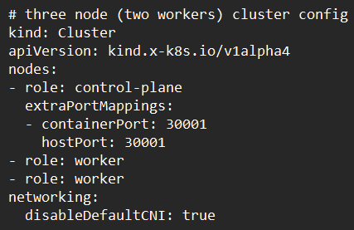
Kind Cluster with calico CNI
- Create a Kubernetes cluster with kind, disabling the default kindnet CNI, and after installing cluster (nodes will not be ready due to no network plugin), installing calico CNI (nodes become ready/running now).
kubectl apply -f https://raw.githubusercontent.com/projectcalico/calico/v3.31.3/manifests/calico.yaml
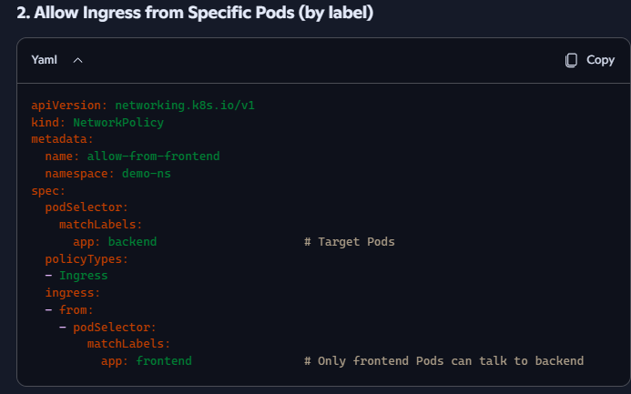
- Pods and services for frontend, backend, and MySQL database are deployed.
- Initial connectivity tests show all pods can communicate freely.
- Example Network Policy YAML to restrict access:
  - Allows ingress traffic to the backend pod only from pods labeled app=frontend.

Network Policy YAML Structure (Key Elements)
YAML Field | Description
apiVersion | Kubernetes API version (networking.k8s.io/v1)
kind | Resource type (NetworkPolicy)
metadata.name | Name of the network policy
spec.podSelector | Selects pods to which the policy applies (by label)
spec.policyTypes | Specifies whether to apply to Ingress, Egress, or both
spec.ingress | Defines allowed ingress rules, including allowed pod selectors and ports
spec.egress | Defines allowed egress rules

Key Insights and Best Practices
- Network Policies enforce pod-level access control, critical for production security.
- A default deny policy is recommended: deny all traffic initially, then allow only necessary communication.
- Always verify that your chosen CNI plugin supports network policies; otherwise, the rules will have no effect.
- Calico is a popular and reliable choice for production environments and supports advanced network policies.
- Proper cleanup of previous CNI configurations is necessary when switching plugins to avoid conflicts.
- Network policies can be complex and must be carefully tested in staging before production deployment.

NetworkPolicy YAML for 3-Tier App
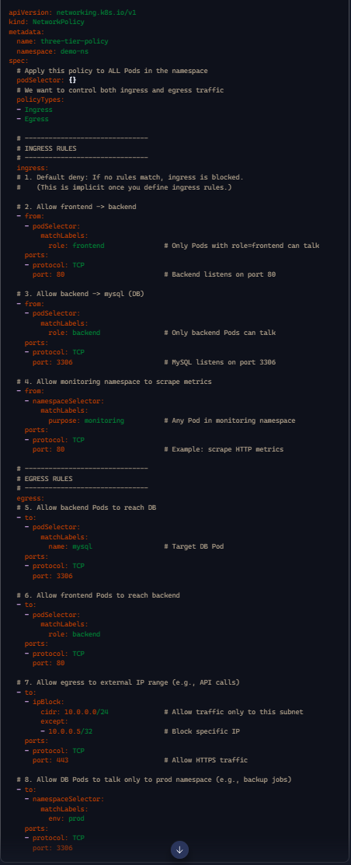
- Default deny: Once you define ingress/egress rules, all other traffic is denied unless explicitly allowed.
- Frontend → Backend: Only Pods with role=frontend can reach backend Pods on port 80.
- Backend → DB: Only Pods with role=backend can reach MySQL on port 3306.
- Namespace-based allow: Monitoring namespace can scrape metrics.
- Egress rules: Explicitly allow frontend to backend, backend to DB, DB to prod namespace, and external HTTPS calls.
- ipBlock: Restricts external traffic to a subnet, with exceptions.

